UID EXPERIMENT 3

NAME: ARUNPRANESH ES ROLL NO:240701051

- COMMAND LINE INTERFACE:
PYTHON CODE:
import os import sys

def rename_file(old_name, new_name):
try:
os.rename(old_name, new_name)
print(f"File renamed from '{old_name}' to '{new_name}'") except FileNotFoundError:
print(f"Error: File '{old_name}' not found.") except PermissionError:
print("Error: Permission denied.") except Exception as e:
print(f"An unexpected error occurred: {e}")

def main():
if len(sys.argv) != 3:
print("Usage: python rename_file_cli.py <old_filename> <new_filename>") sys.exit(1)

old_name = sys.argv[1]

new_name = sys.argv[2]

rename_file(old_name, new_name)

if name == " main ":
main()

OUTPUT:

- GRAPHICAL USER INTERFACE:
PYTHON CODE:
import tkinter as tk
from tkinter import messagebox import os

# Function to rename the file def rename_file():
old_name = old_filename_entry.get().strip()
new_name = new_filename_entry.get().strip()

# Check if input fields are empty if not old_name or not new_name:
messagebox.showwarning("Warning", "Please enter both filenames!") return

# Check if the old file exists
if not os.path.exists(old_name):
messagebox.showerror("Error", f"File '{old_name}' not found.") return

# Check if the new file already exists if os.path.exists(new_name):
overwrite = messagebox.askyesno(
"Warning", f"'{new_name}' already exists. Overwrite?"
)
if not overwrite:
return

try:
os.rename(old_name, new_name) messagebox.showinfo(
"Success", f"File renamed from '{old_name}' to '{new_name}'"
)
except Exception as e:
messagebox.showerror("Error", f"An error occurred: {e}")

# Create main window root = tk.Tk()
root.title("File Renamer") root.geometry("400x150")

root.resizable(False, False) # Fixed window size

# Labels
tk.Label(root, text="Old Filename:", font=("Arial", 10)).grid( row=0, column=0, padx=10, pady=5, sticky="w"
)
tk.Label(root, text="New Filename:", font=("Arial", 10)).grid( row=1, column=0, padx=10, pady=5, sticky="w"
)

# Entry fields
old_filename_entry = tk.Entry(root, width=40)
old_filename_entry.grid(row=0, column=1, padx=10, pady=5)

new_filename_entry = tk.Entry(root, width=40)
new_filename_entry.grid(row=1, column=1, padx=10, pady=5)

# Styled Button
rename_button = tk.Button( root,
text="Rename File", bg="green",
fg="white",
font=("Arial", 10, "bold"), command=rename_file
)

rename_button.grid(row=2, column=0, columnspan=2, pady=10)

# Run the GUI event loop root.mainloop()

OUTPUT:

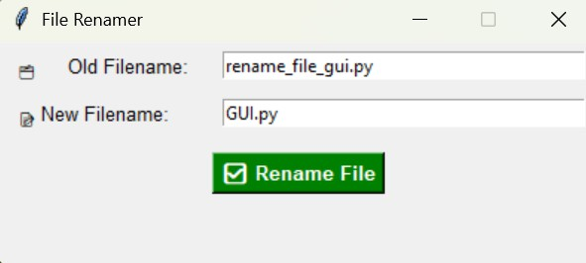

- VOICE USER INTERFACE:
PYTHON CODE:
import speech_recognition as sr import os

def rename_file_from_voice_command(command): try:
command = command.lower()

if "rename" not in command or "to" not in command:
print("Invalid command. Say: 'Rename oldfile.txt to newfile.txt'") return

# Extract filenames using split
before_to, after_to = command.split("to", 1)
old_name = before_to.replace("rename", "").strip() new_name = after_to.strip()

# Check if old file exists
if not os.path.exists(old_name):
print(f"Error: File '{old_name}' not found.") return

# Check if new file already exists if os.path.exists(new_name):
print(f" Error: '{new_name}' already exists.") return

os.rename(old_name, new_name)
print(f" File renamed from '{old_name}' to '{new_name}'")

except Exception as e: print(f"Error: {e}")

def listen_for_command():

recognizer = sr.Recognizer()

try:
with sr.Microphone() as source:
print("Listening for command to rename a file...") recognizer.adjust_for_ambient_noise(source)
audio = recognizer.listen(source)

command = recognizer.recognize_google(audio) print(f” Command received: {command}")
rename_file_from_voice_command(command)

except sr.UnknownValueError:
print("Sorry, I couldn't understand the command.") except sr.RequestError as e:
print(f"Speech recognition service error: {e}") except OSError:
print(" Microphone not found or access denied.")

if name == " main ": listen_for_command()

OUTPUT:

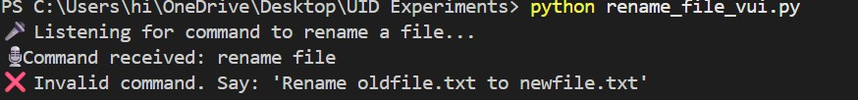
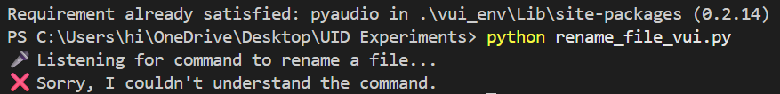

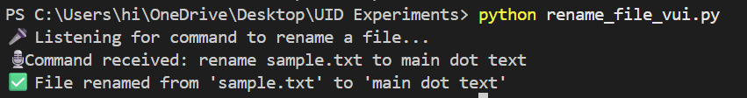
- USER SATISFACTION COMPARISON: PYTHON CODE:
def survey():
print("Rate your satisfaction with the following interfaces (1-5):")

try:
# Get user input for each interface
cli_satisfaction = int(input("CLI (1-5): ")) gui_satisfaction = int(input("GUI (1-5): ")) vui_satisfaction = int(input("VUI (1-5): "))

# Ensure valid ratings
if not (1 <= cli_satisfaction <= 5 and 1 <= gui_satisfaction <= 5 and
1 <= vui_satisfaction <= 5):

print("Please enter ratings between 1 and 5 only.") return

# Display the ratings
print("\nYour satisfaction ratings:") print(f"CLI: {cli_satisfaction}") print(f"GUI: {gui_satisfaction}") print(f"VUI: {vui_satisfaction}")

# Calculate the average satisfaction avg_satisfaction = (
cli_satisfaction + gui_satisfaction + vui_satisfaction
) / 3
print(f"\nAverage Satisfaction Score: {avg_satisfaction:.2f}")

except ValueError:
print("Invalid input! Please enter numbers between 1 and 5.")

# Run the survey function if name == " main ":
survey()

OUTPUT:

